DE–4627
11
DISTANCE EDUCATION
M.Phil. DEGREE EXAMINATION, DECEMBER 2008.
Mathematics
COMMUNICATIVE ALGEBRA
(upto 2006 Batch)
Time : Three hours Maximum : 100 marks
Answer any FIVE questions.
Each question carries 20 marks.
- (a) Define direct sum of submodulus.
Show that 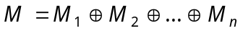 if and only if
(i) 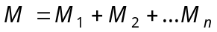
(ii)
for each i, 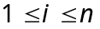.
(b) State and prove Shanuel’s Lemma.
- (a) Define Tensor product of two modules. Show that the tensor product of M and N exists and it is unique upto isomorphism.
(b) Give three definitions for flat module and show that they are equivalent.
- (a) Show that if 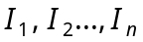 are comaximal then
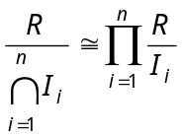.
(b) Show that any finitely generated projective module over a local ring is free.
- (a) Show that 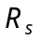 is a flat – module.
(b) Let be an exact sequence of R – modules. Show that M is Noetherian if and only if both 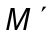 and 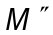 are Noetherian.
- (a) Define irreducible submodule N of M. Show that any irreducible submodule of a Noetherian module is primary.
(b) State and prove the structure theorem of an Arbenian ring.
- (a) Let RCS with S integral over R, 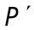, a prime ideal of S and 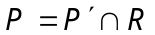. Show that P is a maximal ideal of 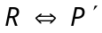 is a maximal ideal of S.
(b) State and prove Going down Theorem.
- (a) Show that if V is a valuation ring of K and P, a prime ideal of V then 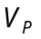 and 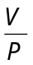 are valuation rings.
(b) Let R be a domain. Show that R is a Dedekind domain every non–zero fractionary ideal of R is invertible.
- (a) Show that
(i) 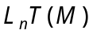 and 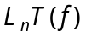 are well defined and independent of the projective resolutions.
(ii) 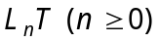 are additive Covariance functions.
(b) Show that an R – module N is infective if and only if
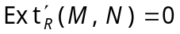 for all R – module M.

–––––––––––––
DE–4628
12
DISTANCE EDUCATION
M.Phil. (Mathematics) DEGREE EXAMINATION, DECEMBER 2008.
MEASURE THEORY
(Upto 2006 Batch)
Time : Three hours Maximum : 100 marks
Answer any FIVE questions.
1. (a) Define algebra, measurable space and measurable sets. (5)
(b) Let u and v be real measurable functions on a measurable space X, let be a continuous mapping of the plane into a topological space Y and define.
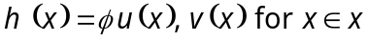. (5)
Then prove that 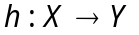 is measurable.
(c) State and prove Lebesgue’s Monotone convergence theorem. (10)
2. In the Riesz representation theorem prove the following.
(a) If 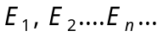 are arbitrary subsets of X, then 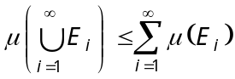. (10)
(b) If K is compact then 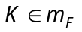 and 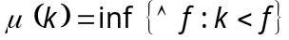. (10)
3. (a) Define Borel measure. when we say a Borel measure as regular. (5)
(b) Let x be a locally compact Hausdorff space in which every open set is -compact. Let be any positive Borel measure on x such that 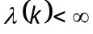 for every compact set K. Then prove that is regular. (15)
4. State and prove Jensen’s Inequality. Using Jensen’s Inequality prove that
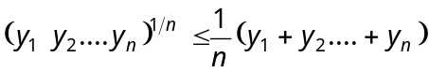 and
Where 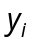 are n positive numbers d 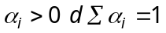.
5. Prove that 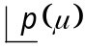 is a complete metric space for 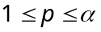 and for every positive measure .
6. State and prove Holder’s inequality.
7. (a) State Radon-Nikodyin theorem. (5)
(b) State and prove Fubini theorem. (15)
8. Suppose 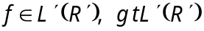. Then prove that
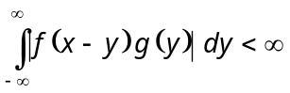 for almost all x.
For these x, define 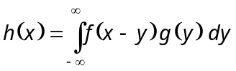. Then prove that 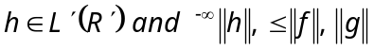.
———————
DE–4629
13
DISTANCE EDUCATION
M.Phil. (Mathematics) DEGREE EXAMINATION, DECEMBER 2008.
TOPOLOGICAL VECTOR SPACES
(Upto 2006 batch)
Time : Three hours Maximum : 100 marks
Answer any FIVE questions.
Each question carries 20 marks.
1. (a) Suppose Y is a subspace of a topological vector space 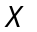 and  is an F-space. Prove that Y is a closed subspace of X.
(b) Suppose 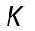 and 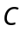 are subsets of a topological vector space 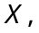 is compact, is closed and 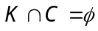 prove that O has a neighbourhood  such that 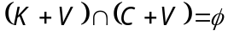. (10 + 10)
2. If is a topological vector space with a countable local base prove the following.
There is a metric d on X such that
(a) d is compatible with the topology of X.
(b) The open ball centered at 0 are balanced
(c) d is invariant : 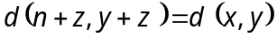 for 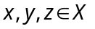
(d) all open balls are convex.
3. (a) Let X be a topological vector space. Prove that the following two properties of a set E in a topological vector space are equivalent.
(i) E is bounded
(ii) If 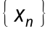 is a sequence in E and 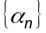 is a sequence of scalars such that 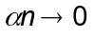 as 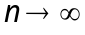 then 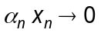 as ,
(b) Prove that a topological vector space X is normable if and only if its origin has a convex bounded neighborhood.
(10 + 10)
4. State and prove the open mapping theorem.
5. (a) Suppose  and 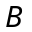 are disjoint, nonempty, convex sets in a topological vector space . Prove the following.
(i) If is open there exist 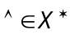 and 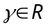 such that 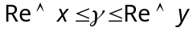 for every 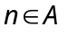 and for every 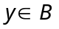.
(ii) If is compact, B is closed and X is totally convex then there exist 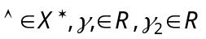 such that 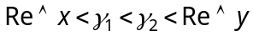 for every 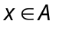 and for every 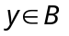.
(b) Suppose X is a vector space and 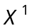 is a separating vector space of linear functionals on X. Prove that -topology 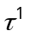 makes X into a locally convex space whose dual space is . (12 + 8)
6. (a) Prove that is a locally convex space , every weakly bounded set is originally bounded and vice versa.
(b) If X is a totally convex space and H is the convex hull of a totally bounded set. Prove that H is the totally bounded.
7. State and prove the Banach-Alaoglu theorem.
8. On every compact group G exists a unique regular Borel probability measure in which is left-invariant. Prove the following :
(a) 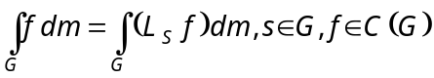
(b) 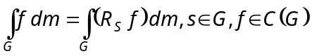
(c) 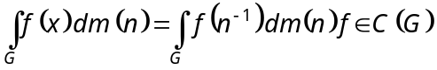.
——————————
14 A
DE-4630
DISTANCE EDUCATION
M.Phil. (Mathematics) DEGREE EXAMINATION, DECEMBER 2008.
FUNDAMENTALS OF DOMINATION IN GRAPHS
(Upto 2006 Batch)
Time : Three hours Maximum : 100 marks
Answer any FIVE questions.
All questions carry equal marks.
(5 × 20 = 100)
1. (a) Show that a dominating set S is a minimal dominating set if and only if for each vertex 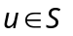 one of the following conditions holds
(i) 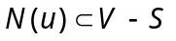
(ii) there exists 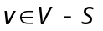 for which 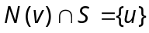.
(b) Show that for any graph G, 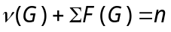.
2. (a) Show that for a graph G with even order and no isolated vertices, 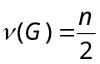 if and only the components of G are the cycles 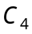 or the corona Hok, for any connected graph H.
(b) Show that if a connected graph G is claw-free and net-free then
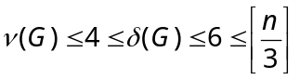.
3. Show that if a graph G has 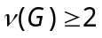 and 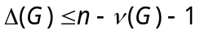 then
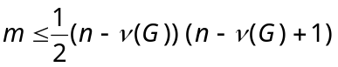.
4. (a) Show that for any graph G, 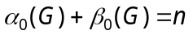.
(b) Show that a dominating set S is a minimal dominating set if and only if it is dominating and irredundant.
5. Show that a sequence 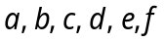 of positive integers is a dominating sequence if and only if
(a) 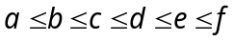
(b) 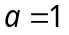 implies that 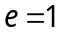
(c) 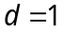 implies that 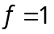
(d) 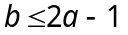.
6. Show that efficient dominating set is NP. Complete
(a) For Bipartite graph
(b) For Chordal graph.
7. State and prove Automorphism Class Theorem.
8. Show that a graph 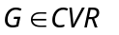 if and only if for each vertex , 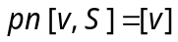 for some set S containing v.

——————
DE–4631
14 B
DISTANCE EDUCATION
M.Phil. (Maths) DEGREE EXAMINATION, DECEMBER 2008.
DATA STRUCTURE AND ALGORITHMS
(Upto 2006 Batch)
Time : Three hours Maximum : 100 marks
Answer any FIVE questions.
All questions carry equal marks.
1. (a) Discuss briefly about constructor and its type.
(b) Discuss the following :
(i) Reference variable
(ii) Vector
(iii) Template.
2. (a) What do you mean by abstract data type?
(b) Discuss and compare doubly and circular linked list with program example.
3. (a) Write a program to multiply two polynomials have M and N terms, using a linked list implementation and prove that the order of computation is 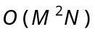 time.
(b) Implement an efficient stack class by using a list as a data member.
4. (a) Write a program to convert a postfix expression to infix.
(b) Write a program to swap two adjacent elements using doubly linked list.
5. (a) Prove that the maximum number of nodes in a binary tree of height h is 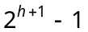.
(b) Write a program for tree preorder traversal.
6. (a) Discuss :
(i) Skewed tree
(ii) Complete binary tree.
(b) Prove that a binomial tree of height K has 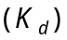 nodes at depth d.
7. (a) Define Acylic Graph.
(b) Describe how to find a minimum spanning tree in an undirected graph.
8. Write Depth-first and Breadth-first search procedure for a given undirected graph.

———————

